**AI Powered Smart Point Of Sale solutions**

(Revolutionising the Indian retail)

**Background**. Indian retail industry has emerged as one of the most dynamic and fast-paced industries due to the entry of several new players. It is world’s 5th largest global destination in the retail space.

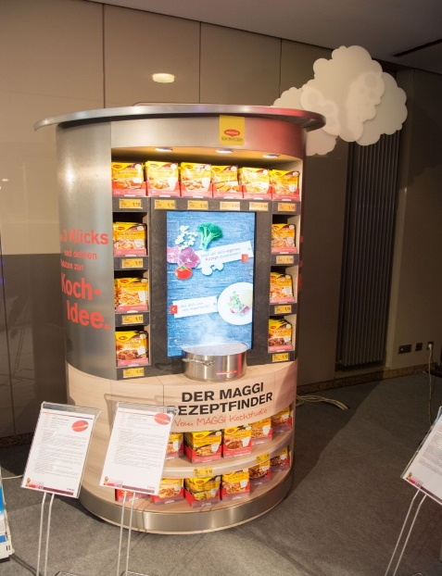

**A POS (Point of Sale) Machine**

**Project Overview**

Student shall be required to work on AI solution for POS (Point of Sale). The analytics shall be meant to suggest shoppers, pushing sales offers. IoT solution shall involve sensor placed on shelves to monitor the products. The IoT information is continuously fed to a cloud based computation and analytics solution as per a pre-defined algorithm.

Here, various issues like context sensitive content for multiple displays etc. shall be analysed to make recommendation to the client in a dynamic manner. This could be through the screen based QR codes etc. Overall, the mechanism shall be centrally controlled from a remote location. The visual content shall also be displayed and monitored centrally through an ‘intelligent’ system.

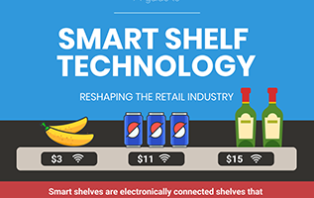

**Sample Smart Shelf**

**Students Role**.

The student shall participate in the development of technology as per following system architecture:-

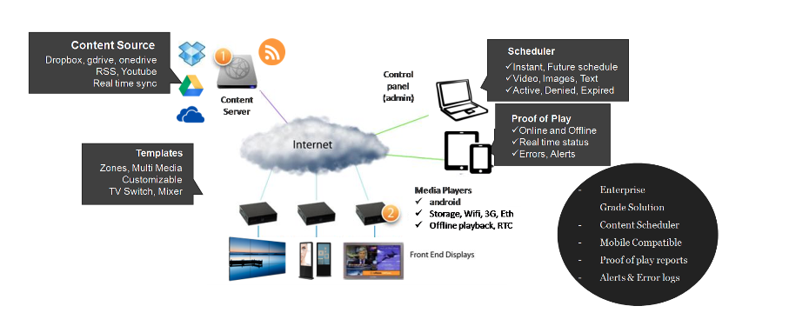

**System Architecture**

Skills gained by every Student at the end of the Project shall be in following fields:-

1. Artificial Intelligence
2. IoT
3. Cloud Computing
4. Smart solutioning
5. Content Management

**Expected workload**

6-8 hours per week (including weekend work)